Possible title for a project:

Identification of environmental impacts of technological innovations from nanotechnology, biotechnology and ICT for food processing applications

European Network of Excellence ‘HighTech Europe’
- Introduction
HighTech Europe is the first Network of Excellence for the food processing sector. It facilitates communication and knowledge transfer between industry and science in order to increase innovations in food technology across Europe. The network aims to achieve a durable integration of European R&D activities into high-tech food processing. Members of HighTech Europe are 22 partners from universities, applied research centres, technology transfer centres, food associations and enterprises.
Biotechnology, nanotechnology and ICT (information and communication technology) are considered as areas with high innovative power, thus serving as promising sources for future food processing technologies.
By an evaluation process – named the Science Cube approach – the relationships between these three sources of innovation and the basic food engineering operations (separating, structure forming, stabilizing, converting and packaging) as well as the underlying scientific principles (physical, chemical and biological) are assessed (Fig. 1).
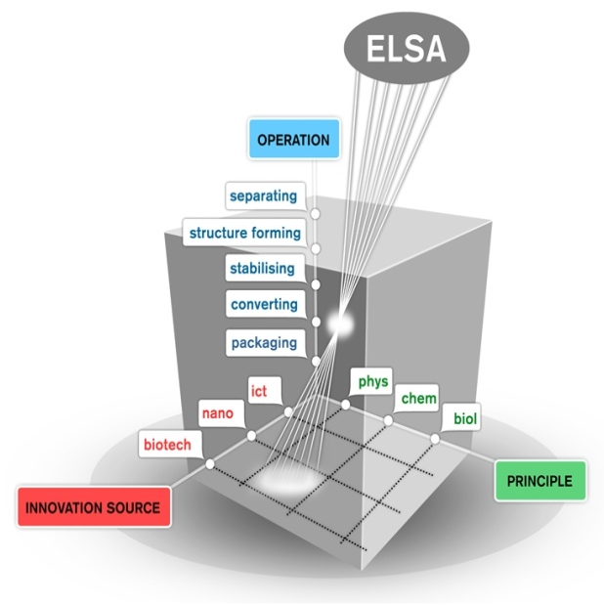

Fig.1. Science Cube approach demonstrating the relationships between sources of innovation, food process engineering operations and the underlying scientific principles under consideration of ELSA
Besides, special attention is paid on ethical, legal and social aspects (ELSA), on consumer perception regarding high-tech food processing, on food-specific regulatory and safety issues. For applicability to SMEs, the results of the Science Cube approach are matched with collected industrial needs.
The final goal is to set up an European Institute of Food Processing. It will co-ordinate specific research, development and dissemination tasks. Furthermore it will serve as a consulting and training platform for technological implementation and legal compliance. In this way, the innovation rate and competitiveness of the European Agro-Food sector should be increased.

- Overall strategy and general description

HighTech Europe aims at accelerating the innovation process in European food industries, SMEs in particular, by pooling a critical mass of competence and skills all along the knowledge transfer chains. The joint research activities will be focused towards creation of best cases with a high impact on improving food quality and safety, increasing the processing efficiency and being in line with consumer expectations and compliant with the regulations of the European food legislation. The underlying objective of this activity is not only to bring integration a step further and to improve effectiveness and robustness of collaborative R&D work, but also to stimulate the uptake of HighTech Europe’s identified technologies by potential end-users, in particular SMEs.
In the process towards a sustainable European food processing organisation, one of the key issues is:
- Identification and evaluation of available and forthcoming technological tools (workpackage 2). Since expertise is scattered, a Science Cube approach is chosen to link fundamental principles with innovation sources and processing applications. The Network serves as a mechanism to screen potentially applicable scientific findings – via the Lighthouse Watcher concept – and promote synergisms between university scientists and those in applied research centres and in industry.

- Description of work

A systematic screening process – the so-called Science Cube approach – will be developed and installed, which identifies, evaluates, tests and classifies applicable inputs from innovation sources (nanotechnology, biotechnology and ICT) and principles (biological, chemical and physical) and their impact on food processing engineering operations (fig.1.). The latter can be classified in separating, structure forming, stabilizing, and converting operations and packaging.
The complexity of food matrices – in terms of structure, formation and functionality (dynamical changes) – often leads to long development trajectories to reach real innovations.
This work package will provide tools to overcome delays by a better understanding of the interference of innovation sources, principles and food processing and how this interaction can be controlled. An in-depth study on the most promising applications will be conducted by combining potential innovations with process needs.

Task: Challenge innovation sources for exploitation in food processing
The potential of technological innovations from nanotechnology, biotechnology and ICT for food process engineering applications will be challenged by identifying potential benefits that arise from replacing traditional processing means by advanced technologies. Appropriate simulation tools will be applied to the identified innovative principles to predict the benefit for technology replacement or modification.

The focus is on operation, conventional technologies at first. To that end, a matrix was developed to list conventional technologies with their shortcomings and possible solutions (see the technology data sheet below).

Subtask: Stabilizing processes
- identifying crucial limitations and shortcomings in food industry's stabilizing processes
- based on the expertise of the beneficiaries involved and making use of simulation tools a priority list of those innovations that potentially match the needs will be prepared and compiled in a matrix

Subtask: Packaging
- identifying crucial limitations and shortcomings in food industry’s packaging processes
- based on the expertise of the beneficiaries involved and making use of simulation tools a priority list of those innovations that potentially match the needs will be prepared and compiled in a matrix

Task: Feasibility studies

The technological knowledge and technologies identified in the task above will be further investigated with respect to their potential applicability in different areas of the food industries. For this purpose, one feasibility study for each technological area will be implemented.
This includes the development of a matrix for the optimal matchmaking between available technological knowledge & technologies and industry & consumer requirements; a set of standard parameters to characterise and compare economic efficiency of different solutions for different applications; environmental aspects and components of ELSA.
Based on the results of the feasibility studies, a ranking list of the most promising technical approaches will be compiled.

ANNEX

The technology sheet should be completed keeping the following in mind (comments in blue were raised during the meeting):

Identification | Title
Identification | Give concise name
Identification | Key words and relations
Identification | Key words and relations to tag this data sheet using the ontology. Each key word should be separated by a “,”.
Identification | Latest version
Identification | Date of latest version (yyyy-mm-dd)
Identification | Completed by
Identification | List of all beneficiaries (institute’s name) that have contributed (for instance through editing)
Identification | Subtask
Identification | Subtask this data sheet has originally been created for (this can be more than one subtask)
Identification | Principle(s)
Identification | Physical – chemical - biological – not applicable (only describe the principle that’s behind the technology/tool; not what it will be applied on)
Identification | Operation(s)
Identification | Separation – stabilizing – structure forming – conversion – packaging – other – not applicable
Identification | Innovation source(s)
Identification | ICT – biotechnology – nanotechnology – other – not applicable (only choose one of this list if technology/tool is really related to this innovation source)
Identification | Database search history
Identification | This is internal information. Here you can describe how you got to the information: what database was used? What search terms were used?
What does this technology do? | Primary objective of technology/innovative tool
What does this technology do? | What is the technology designed for? This can be one of the HTE operations.
What does this technology do? | Working principle
What does this technology do? | Describe in understandable terms how the technology works. Not too detailed, not too vague. (Don’t describe the procedure here, only the principle. If you want to insert a picture/drawing/... here (or elsewhere), you can do that using the free text window)
What does this technology do? | Additional effects
What does this technology do? | Describe which side effects the technology has, besides its primary objective. These can be positive and negative.
What does this technology do? | Important parameters
What does this technology do? | What are important parameters to reach the objective? For instance: process parameters, product characteristics. (clearly distinguish between both)
What can the technology be used for? | Product
What can the technology be used for? | What type of products can this technology be used for?  (Here you can add application fields; new Wiki Pages can be created for operations on specific food categories. These should than be linked with the more general Wiki page. This will require a concise and unique link. For instance: “high pressure processing of meat” instead of “meat”)
What can the technology be used for? | Operations
What can the technology be used for? | In what kind of operations can this technology be used?  (The link to the same operation on a more specific food category might be better placed here)
What can the technology be used for? | Match with potential needs/short comings
What can the technology be used for? | This is internal information. Which potential industrial need or problem can this technology resolve? Does this technology match one of the industrial needs collected in WP3? Can this technology replace or complement a conventional technology? (This field indicates what problems related to conventional technologies can be solved with the technology. It can also be used by WP3 to suggest technology sheets based on industrial needs. An ontology-based link should be made between this field and the “what can this technology not be used for” field in the technology sheet of the conventional technology)
What can the technology not be used for? | Restricted products
What can the technology not be used for? | What type of products can this technology not be used for?
What can the technology not be used for? | Restricted operations
What can the technology not be used for? | In what kind of operations can this technology not be used for? For instance: it can be used for pasteurisation, but not for sterilisation.
What can the technology not be used for? | Other limitations
What can the technology not be used for? | What are the other limitations of this technology (besides the ones mentioned above, products and operations)? This field can be used to demonstrate the shortcomings in conventional technologies. (An ontology-based link should be made between this field and the “Match with potential needs/short comings” field in the technology sheet of the innovative technology)
What can the technology not be used for? | Risks/hazards
What can the technology not be used for? | Are there any risks or hazards related to this technology?
Is the technology easily implemented? | Maturity
Is the technology easily implemented? | Specify the maturity of this technology. Is it only available at lab scale; are scale-up problems to be expected, ….?
Is the technology easily implemented? | Modularity/implementation
Is the technology easily implemented? | Can this technology be inserted in an existing production line or does it replace the whole or a major part of the production line? (based on the decomposing of the industrial needs into key words it was shown that in this field also facility/equipment should be described)
Is the technology easily implemented? | Consumer aspects
Is the technology easily implemented? | Include if any information concerning consumer acceptance of the technology is available (i.e. will the consumer accept products that have been processed with this technology?)
Is the technology easily implemented? | Legal aspects
Is the technology easily implemented? | Include if any legislative information concerning the technology is available (if no information is available, write “Please check local legislation”)
Is the technology easily implemented? | Environmental aspects
Is the technology easily implemented? | Include if any information concerning environmental impact of the technology is available
Where can I find more information? | Institutes
Where can I find more information? | List centres of excellence in the domain of this technology. HTE institutes will be linked through their profile sheet. Others will be invited to complete their profile sheet. (As this is a European project, European institutes are prioritized. Don’t forget about HTE beneficiaries)
Where can I find more information? | Companies
Where can I find more information? | List companies that produce the equipments needed for this technology. HTE companies will be linked through their profile sheet. Others will be invited to complete their profile sheet. (As this is a European project, European companies are prioritized)
Where can I find more information? | References
Where can I find more information? | List the references used for creating this technology data sheet.(These can be listed as free text, as we won’t keep a database)

